Aasish Tammana

CSE 571 – Artificial Intelligence

Homework 4

**Exercise 1.1**

1. The knowledge base can be represented as follows:

Statement 1:

It is given that a breeze is perceived in [2,1]. This means there might be a pit in position [2,2] or in [3,1] or in both these locations. It can be represented in first order logic as follows:

P[2,2] ᴠ P[3,1]

Statement 2:

This also means no pit in [1,3]

⌐P[1,3]

Statement 3:

There is no breeze in [1,2] and hence no pit in [2,2]

⌐P[2,2]

Statement 3:

This also means no Wumpus in [3,1]

⌐W[3,1]

Statement 4:

Similarly, A stench in [1,2] implies there is a possibility of Wumpus in [1,3] or [2,2]. Also, it is mentioned that there is only one Wumpus.

(W[1,3] ᴧ ⌐W[2,2]) ᴠ (⌐W[1,3] ᴧ W[2,2])

Statement 5:

We know that, if Wumpus was present in [2,2] there should have been a stench in [2,1]. However, this is not the case. This means there is no Wumpus in [2,2]

⌐W[2,2]

Combining 1,2,3 we obtain C1= P[3,1] ᴧ ⌐P[2,2] ᴧ ⌐P[1,3]

Combining 4,5,6 we obtain C2= W[1,3] ᴧ ⌐W[2,2] ᴧ ⌐W[3,1]

The possible world for these 3 positions can be given in the below format.

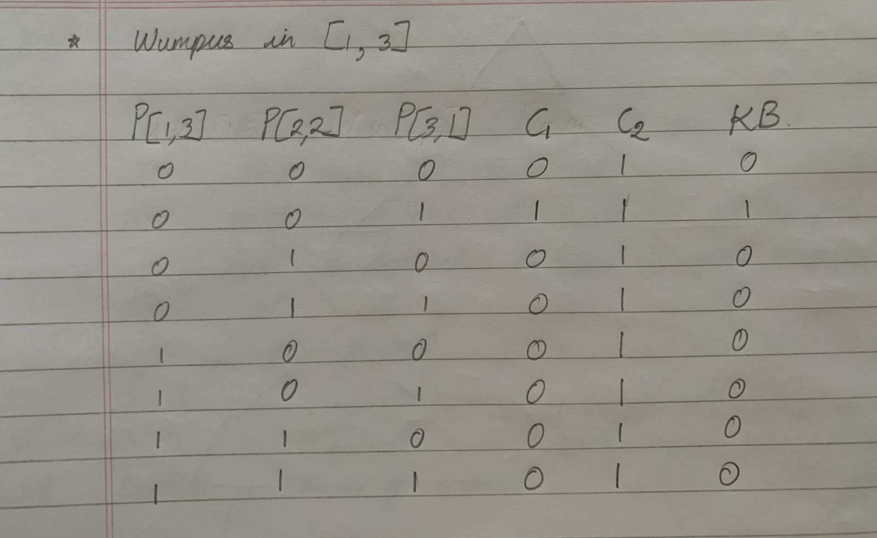

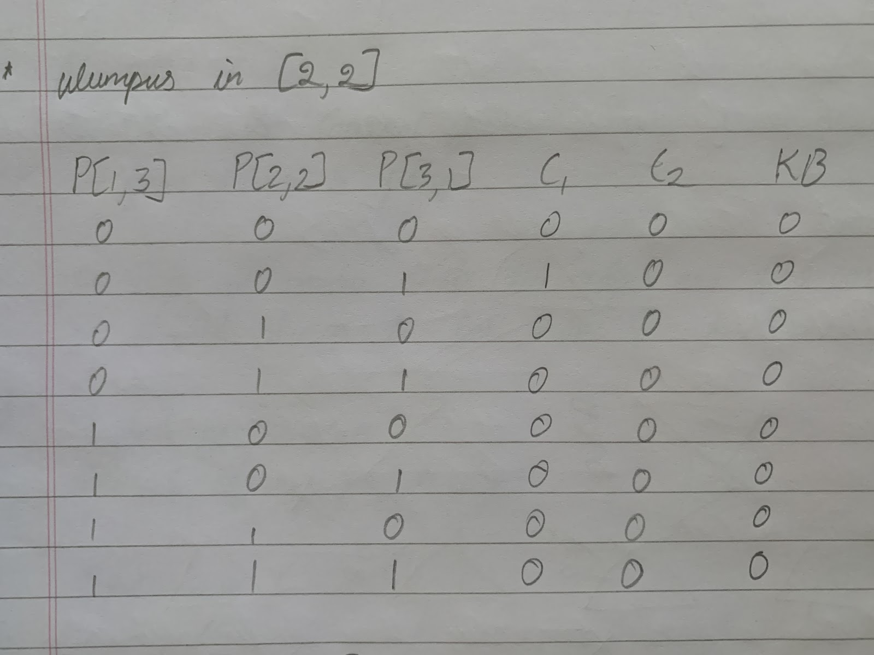

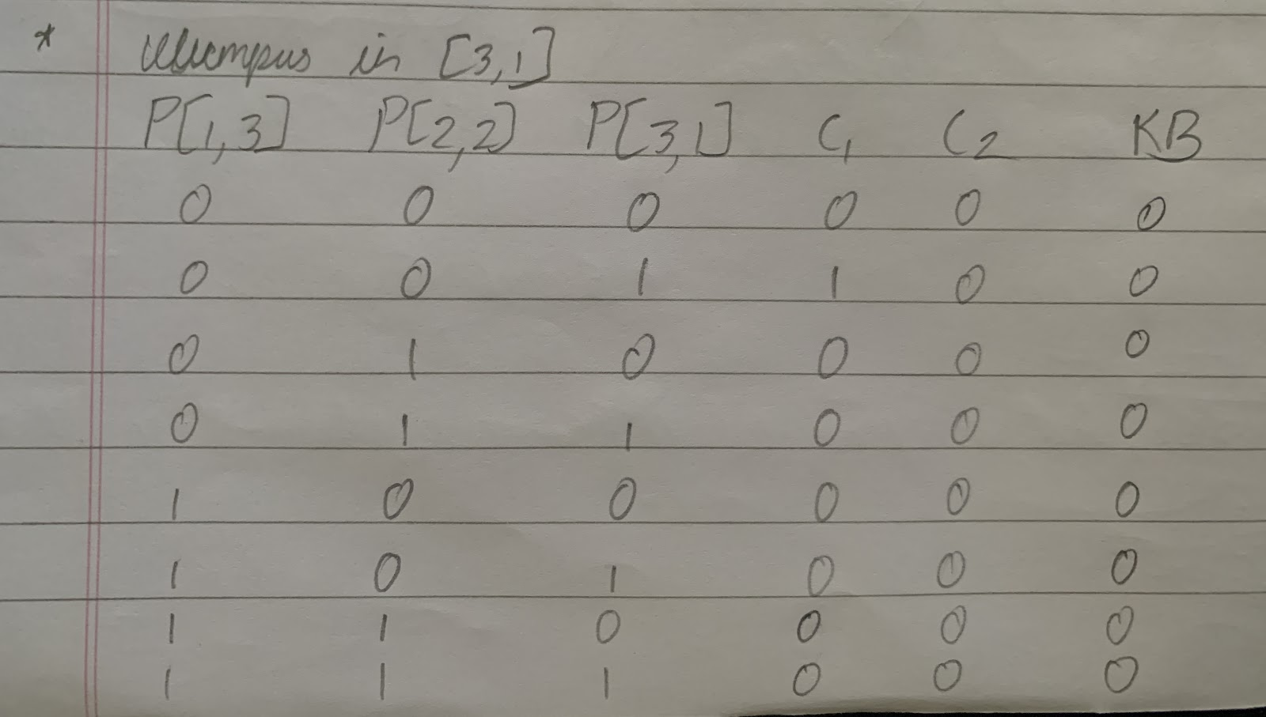

1. KB is true only when all the statements are satisfied.

This means, Pit only in [3,1] and Wumpus in [1,3]

Similarly, For α2 we have no pit in [2,2] which will be 1 when P[2,2]=0

For α3 we have Wumpus in [1,3] which will be 1 only in case 1.

The models can be represented as follows:

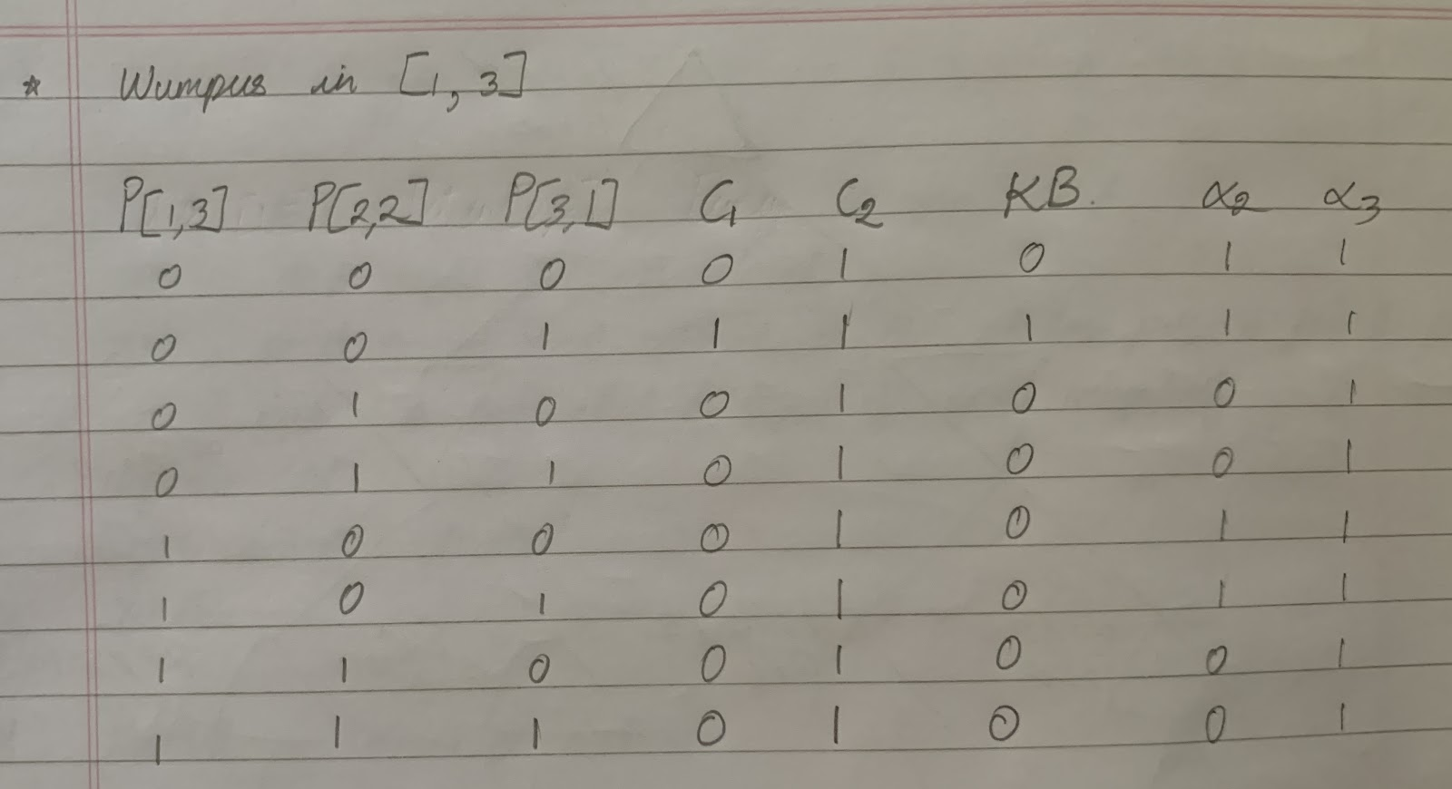

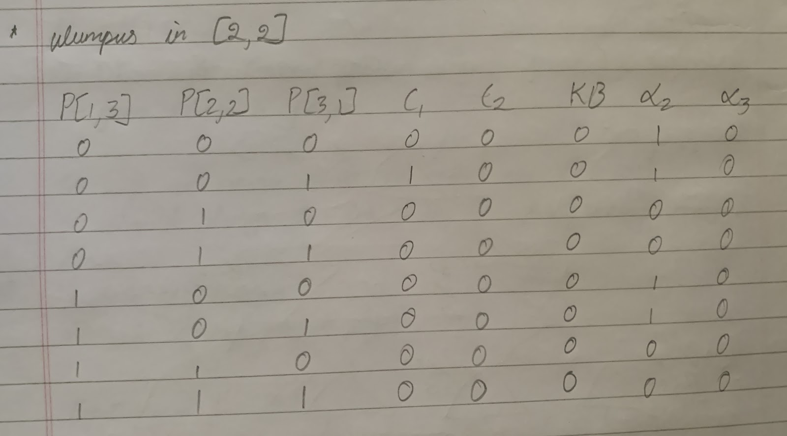

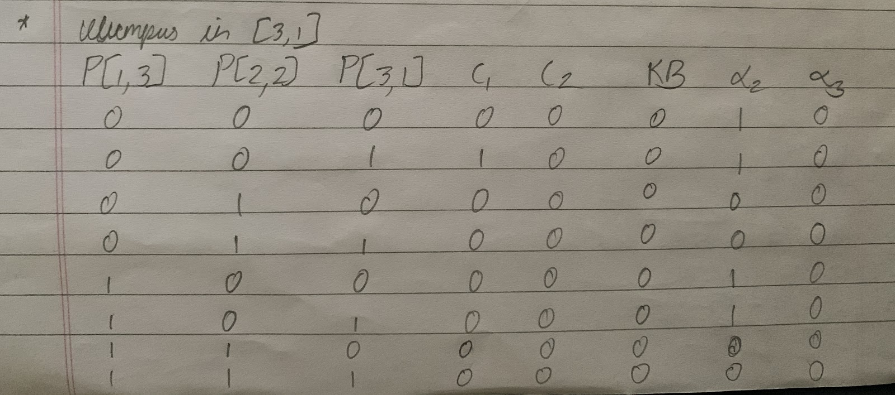

We can see that α2 and α3 are true where the Knowledge Base is true.

This means that KB ⊨ α2 and KB ⊨ α3.

If Knowledge base is true, there is no pit in [2,2] as represented in diagram.

If Knowledge base is true, there is Wumpus in [1,3]

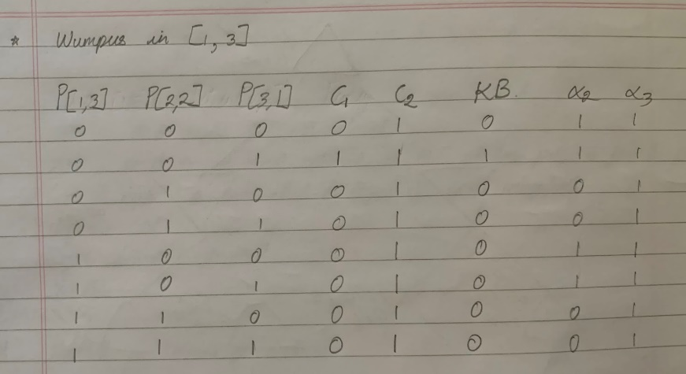

1. As per lecture slides, From basic evaluations, we know that

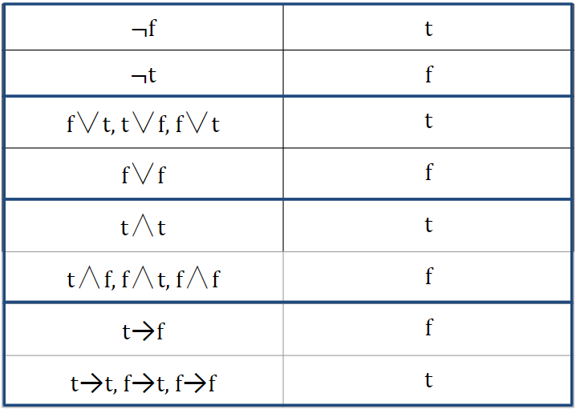

From this we can observe that,

1. B and C will be true if either one of them is true or both are true. Otherwise, it would be false. Therefore, we can say that

B ᴠ C is true in 3 out of 4 models (It is false when both B and C are false)

As the vocabulary does not depend on the values of A and D, they can be either true or false which implies the total number of worlds is (A=True/False) *(D=True/False) *(B ᴠ C which is true for 3 models)

* 2*2*3=12 models

1. The given vocabulary would result in false only when all the propositions A B C D are true.

* Total number of models =24 – 1 = 15 models

1. The given vocabulary can be split into 2 parts

(A ⇒ B) and A ᴧ ¬B ᴧ C ᴧ D

The first part will always be false only when A is true and B is false

The second part will be true when A, C, D are true and B is false.

But both parts are contradictory i.e if B is false and A is true, first part results in false which implies no model satisfies condition.

* 0 models

**Exercise 1.2**

1. p→q is false when p is true and q is false, otherwise true.

Similarly, r→s is false when r is true and s is false, else true.

Hence (p→q) ᴧ (r→s) is true only when (p→q) and (r→s) are true respectively.

p ᴠ r is false when both p and r are false.

q ᴠ s is false when both q and s are false.

Therefore (p ᴠ r) → (q ᴠ s) is false only when (p ᴠ r) is true and (q ᴠ s) is false.

From this we can observe that whenever (p ᴠ r) → (q ᴠ s) is true, (p→q) ᴧ (r→s) is also true. Hence, we can say that property of entailment is satisfied.

The expression on the left checks (p or r) implies (q or s) and on the right we check p implies q and r implies s.

1. q→p is false when q is true and p is false, otherwise true.

p ᴠ (q→p) also satisfies the same condition i.e the proposition is false only when q is true and p is false.

(p ᴠ (q→p)) ᴧ q , This proposition is true only when P and Q both are true, else it is false.

(p ᴠ (q→p)) ᴧ q → p definitely satisfies entailment because whenever (p ᴠ (q→p)) ᴧ q is true, p is also true.

The expression on the left involves “or” with p and right checks for p

1. (q ᴠ r) is false when both are false.

p→(q ᴠ r). This is false only when p is false and (q ᴠ r) is false i.e all three p,q,r are false.

q→s is false when q is true and s is false

r→s is false when r is true and s is false

p→s is false when p is true and s is false.

Hence whenever (p→(q ᴠ r)) ᴧ (q→s) ᴧ (r→s) is true p→s is also true. The expression on the left has p “implies” along with conjugation on s which is indirectly p implies s on the right.

**Exercise 1.3**

Statement 1:

Given that [1, 1] → [1, 2] and observes a breeze in [1, 2]

This means there’s a pit either in [1,3] or [2,2] or both

This can be represented as P[1,3] ᴠ P[2,2]

Statement 2:

Then the agent moves back to [1,1] i.e [1, 2] → [1, 1] which we already know is Ok. Since there is no breeze or stench in [1,1] it means that [2,1] is also safe to move. Agent makes a move from

[1, 1] → [2,1] and observes a stench here. This means that Wumpus is either in [2,2] or [3,1]. This is represented as W[2,2] ᴠ W[3,1]

Statement 3:

From Statement 1 we know that [2,2] might have a pit. But if that is the case we should have a breeze in the current position [2,1]. Since there is no breeze, this confirms 3 things.

* No pit in [2,2] which is represented as ⌐P[2,2]
* There must be a pit in [1,3] which is represented as P[1,3]
* Wumpus is present in [3,1] as there was a stench in [2,1] which can be represented as W[3,1]

Statement 4:

Since it is safe to go to [2,2] (From statement 3), agent moves from [2,1] → [2,2] and senses that the cell is safe as there is no stench or breeze in this position. Here the agent has 2 options, to go to [2,3] or [3,2]. Since there was a stench in [2,1] and we have identified the position of the Wumpus, agent can choose any of the 2 options.

We identify that [2,3] is okay and confirm the presence of Wumpus in[3,1] due to the stench/breeze/glittering in [3,2]

Given, Breeze B, Stench S and Glitter G. Let us say the state “OK” is represented by “O”

The first 3 actions can be depicted as below:

O[1,1] ᴧ B[1,2] ᴧ ⌐B[2,1] ᴧ ⌐S[1,2] ᴧ S[2,1]

Rules:

1. O[1,1] → ⌐P[1,1] ᴧ ⌐W[1,1]
2. B[1,2] ᴧ ⌐B[2,1] → P[1,3]
3. ⌐S[1,2] → ⌐W[1,1] ᴧ ⌐W[1,3] ᴧ ⌐W[2,2]
4. S[2,1] → W[1,1] ᴠ W[2,2] ᴠ W[3,1]

By the rules, to determine the Wumpus position, we can say that

1 means O[1,1] → ⌐W[1,1]

3 means ⌐S[1,2] → ⌐W[2,2]

4 means S[2,1] → W[1,1] ᴠ W[2,2] ᴠ W[3,1]

Combining 1,3 & 4 we arrive at the conclusion O[1,1] ᴧ ⌐S[1,2] ᴧ S[2,1]╞ W[3,1]

**Exercise 1.4**

1. Let us define the vocabulary as follows

Agent(a) means a is an agent

Policy(a) means a is a policy

People(a) means a is a person

Sell(a,b,c) means a sells b to c

Insured(a) means a is insured

As per the statement

Agent is Agent(a)

Agent a selling policy b to a person c is Sell(a,b,c)

Person c not insured is ¬Insured(c)

Ǝa (Agent(a) ᴧ ∀b,c Policy(b) ᴧ Sell(a,b,c) → (People(c) ᴧ ¬Insured(c))

1. Let us define the vocabulary as follows

Politician(a) means a is a politician

Fool(a,b,t) means ‘a’ makes a fool of b at time t

People(a) means a is a person

Politician is Politician(a)

Fooling some people all the time is Ǝb ∀t People(b) ᴧ Fool(a,b)

Fooling all people some of the time is ∀b Ǝt People(b) →Fool(a,b)

Fooling all people all the time is ∀b ∀t People(b) →Fool(a,b)

∀a (Politician(a)) → (Ǝb ∀t People(b) ᴧ Fool(a,b))ᴧ(∀b Ǝt People(b) →Fool(a,b)) ᴧ ¬(∀b ∀t People(b) →Fool(a,b))

1. Let us define the vocabulary as follows

Wumpus(a) means ‘a’ is a Wumpus

∀a Wumpus(a) → ∀b Wumpus(b)

For all values of ‘a’, if ‘a’ is Wumpus and for all values of ‘b’, if b is Wumpus -> this means a = b, hence there is only one Wumpus in the world.

1. Let us define the vocabulary as follows

Wumpus(a) means ‘a’ is a Wumpus

Next(a,loc) means next adjacent location loc of ‘a’

Stench(a) mean ‘a’ is smelly

Next(a,loc) ᴧ wumpus(a) means adjacent location of wumpus

Therefore ∀a (Next(a,loc) ᴧ wumpus(a)) → Stench(loc)

1. Let us define the vocabulary as follows

Pit(a) means ‘a’ is a pit

Breeze(a) means a is breezy

Next(a,loc) means next adjacent location loc of ‘a’

∀a Breeze(a) → Ǝ loc (Next(a,loc) ᴧ Pit(loc))

**Exercise 1.5**

All babies are illogical

Nobody is despised who can manage a crocodile

Illogical persons are despised

Let us define the vocabulary as follows

Baby(a) means ‘a’ is a baby

logical(a) means ‘a’ is logical

Despised(a) means ‘a’ is despised

Manage(a) means ‘a’ can manage a crocodile

The statements can therefore be translated into

∀a Baby(a) → ¬logical(a)

∀a Manage(a) → ¬ Despised(a)

∀a ¬logical(a) → Despised(a)

Now we convert the FOL to CNF

Statement 1: ¬ Baby(a) ᴠ ¬logical(a)

Statement 2: ¬Manage(a) ᴠ ¬ Despised(a)

Statement 3: logical(a) ᴠ Despised(a)

Let us assume If it is a baby, it cannot manage a crocodile.

This is represented as Baby(a) → ¬ Manage(a)

Now adding this to Statement 2, 3 we get ¬Manage(a) ᴠ logical(a)

Adding 1 and output we get, ¬ Baby(a) ᴠ ¬Manage(a)

Negating this we obtain Baby(a) → Manage(a) which is contradictory to the assumption

Hence if negation is contradictory, we can say that the assumption is true.

Which means If it is a baby, it cannot manage a crocodile i.e

∀a Baby(a) → ¬ Manage(a)

Let us define the vocabulary as follows:

Knight(a) means a is the knight

Knave(a) means a is the knave

Spy(a) means a is the spy

Truth(a) means a is telling the truth

Lie(a) means a is lying.

Given statements:

1. Alex says Knave(Cody)
2. Ben says Knight(Alex)
3. Cody says Spy(Cody)
4. Truth(Knight)
5. Lies(Knave)

Assumption: Knight(Ben) and Truth(Knight) implies Knight(Alex)

Knight(Ben) ᴧ Truth(Knight) → Knight(Alex)

Conclusion: There is only one knight. Therefore, Ben is not the knight i.e

¬ Knight(Ben)

Assumption: Knight(Cody) and Truth(Knight) implies Spy(Cody)

Knight(Cody) ᴧ Truth(Knight) →Spy(Cody)

Conclusion: We know there is only one knight. Therefore, Cody is not the knight i.e ¬ Knight(Cody)

Hence, we can conclude that Alex is the knight i.e Knight(Alex)

Truth(Knight) implies Knave(Cody) i.e Truth(Knight) → Knave(Cody)

And together these imply Spy(Ben) i.e

Knight(Alex) ᴧ Knave(Cody) → Spy(Ben)

Now if we assume that Alex is not the knight 1.e ¬ Knight(Alex)

There are 2 possibilities which means

Spy(Ben) ᴠ Knave(Ben) i.e

¬ Knight(Alex) → (Spy(Ben) ᴠ Knave(Ben))

Case 1 : Spy(Ben)

Spy(Ben) ᴧ ¬ Knight(Alex) → Knave(Alex) ᴧ Knight(Cody)

However, Truth(Knight) and Knight(Cody) would imply Spy(Cody) which is not possible.

Hence by resolution, we can say Knight(Alex) is true.

Case 2 : Knave(Ben)

Knave(Ben) ᴧ ¬ Knight(Alex) → Spy(Alex) ᴧ Knight(Cody)

Again, Truth(Knight) and Knight(Cody) would imply Spy(Cody) which is not possible.

Hence by resolution, we can say Knight(Alex) is true.